Regressions and Output in R

Data Set Up

Once we have the data that we need, we want to be able to analyze the data using some form of regression analysis. We will cover the most basic in R which is the linear model using the lm() command. There are packages for just about any type of regression you may wish to run and to find them you need only to do a Google search for the type of regression you wish to run. What we will focus on for this lecture is the basic command and its options, the various aspects of the output created when we use that command, and how to display the results.

Before we start, however, we have left one key element out of our original scripts that we have completed so far and that is the saving of the data. We can recall data in one of two ways. The first is to use the source() command to run another existing script from the current script. While this ensures we have the most recent version of the data and we have the right sequencing of the scripts, some scripts may take a longer time to run. The other option is to simply save the data using either the save() or save.image() command to save the data into a file with the .RData extension. The save() command allows you to denote which elements in the environment you wish to save while the save.image() command saves everything in the environment. The syntax for the commands is below.
save(df, file="~Projects/ECON591JRG/Analysis/Input/df.RData")
save.image(file="~Projects/ECON591/Analysis/Input/df.RData")

Now given our directory structure that we have been using, we could either save this output in the OUTPUT sub-directory under BUILD, or we could save the data in the INPUT sub-directory under ANALYSIS. Either method is okay, we will opt to save the data in the INPUT sub-directory under ANALYSIS. To do this, we need to reopen all the scripts that we have done so far and add the following code to the end where the df stands for the name of the dataframe containing our final data set.

Since the data we need to bring over the vote data we got by scraping the web, we will got back to our script from last week and add the following two commands
votes<-rbind(kentucky,indiana,illinois,missouri,wisconsin,iowa)
save(votes,file="./Build/Output/votes.RData")

Below we start a new script which is to collect all the data we need for this lecture. Typically, this would have been done in the previous scripts and some of it should look like your homework. The first part of the script just calls the census api once more and pulls down the state data at the county level. Then we use the same cleaning command in the script last week and the assign() command to name each of the states. The one change here is the st_area() command which is used to generate the geographic information we need to create an outline of the individual states which we then summarize() inside a piped command and then assign the result as the map for each state. The rbind() command stands for row binding and it stacks dataframes on top of each other provided they have the same columns names. We use this to collect our census and map data into single dataframes. The k object is used to keep track of the state names since we are looping over the FIPS codes and since we want it to advance one, we simply add one to the existing k.

#This script creates the data needed for the regression lecture.
#Jeremy R. Groves
#September 5, 2020

rm(list=ls())

#Generate data from Census API
#Pre-defining variables to be used in loop

vars<-c("B01001_001","B01001_002","B02001_001","B02001_002", "B02001_003","B05001_001","B05001_006","B07001_001", "B07001_017","B07001_033","B07001_049","B07001_065","B07001_081" )

states<-c("kentucky","indiana","illinois","missouri","wisconsin","iowa")
fips<-c(21,18,17,29,55,19)

#API Command
k<-1

for(i in fips){
acs<-get_acs(geography="county",
variables = vars,
state = i,
year = 2016,
geometry = TRUE)

temp<-acs %>%
mutate(variable2 = case_when(variable=="B01001_001" ~ "TotPop",
variable=="B01001_002" ~ "Male",
variable=="B02001_001" ~ "TotRace",
variable=="B02001_002" ~ "White",
variable=="B02001_003" ~ "Black",
variable=="B05001_001" ~ "TotCit",
variable=="B05001_006" ~ "NonCit",
variable=="B07001_001" ~ "TotMob",
variable=="B07001_017" ~ "Stay",
variable=="B07001_033" ~ "SameCounty",
variable=="B07001_049" ~ "SameSt",
variable=="B07001_065" ~ "OthState",
variable=="B07001_081" ~ "Abroad",
TRUE ~ "other")) %>%
select(!c(moe,variable)) %>%
spread(key=variable2, value=estimate) %>%
mutate(perMale = Male/TotPop,
perWhite = White/TotPop,
perBlack = Black/TotPop,
perCit = 1-(NonCit/TotCit),
perStay = Stay/TotMob,
perSameCounty = SameCounty/TotMob,
perSameSt = SameSt/TotMob,
perOthState = OthState/TotMob,
perAbroad = Abroad/TotMob) %>%
select("GEOID","NAME",starts_with("per"),"geometry") %>%
mutate(state = states[k])

assign(paste0(states[k],"census"),temp)

temp$area<-st_area(temp)
map <- temp %>%
summarise(area = sum(area)) %>%
mutate(state = states[k])

assign(paste0(states[k],"map"),map)
k<-k+1
rm(temp, map)
}

The next chunk of code will set up the vote data for the counties and then merge it with the census data. Remember that we must fix the two Illinois counties (DeWitt and JoDaviess) and we will find a few more that need fixed in the other states using the same method we did before.

census<-rbind(illinoiscensus,iowacensus,kentuckycensus,wisconsincensus,
missouricensus,indianacensus)

states<-rbind(illinoismap,iowamap,kentuckymap,wisconsinmap,missourimap,
indianamap)

census$NAME<-as.data.frame(str_split_fixed(census$NAME, ",", 2))[,1]
census$NAME<-trimws(gsub(" County","",census$NAME))

#Load Vote Data
load("./Build/Output/votes.RData")

votes$County[which(votes$County=="DeWitt")]<-"De Witt"
votes$County[which(votes$County=="JoDaviess")]<-"Jo Daviess"
votes$County[which(votes$County=="LaClede")]<-"Laclede"
votes$County[which(votes$County=="LaRue")]<-"Larue"
votes$County[which(votes$County=="St. Louis City")]<-"St. Louis city"
census$NAME[which(census$NAME=="St. Louis")]<-"St. Louis County"

#Merge vote and census data

core<-merge(census,votes,by.x=c("NAME","state"), by.y=c("County","state"),all=TRUE)

core$area<-st_area(core) #Command for maps in ggplot later

More Cool Pictures

Before we move to regressions, lets revisit the idea of data visualization. We now have data from six states and we would like to display how those states look together, similar to our IL maps from before. This is why we bound map dataframes into the states dataframe and then found the areas. Using the geom_sf() we can create maps and put a nice outline on them. Below is the code and output from maps showing the percentage of people that moved from another state and the percentage of votes received by Clinton (and by extension the percentage of votes for Trump).
ggplot(core)+
geom_sf(aes(fill = perWhite))+
scale_fill_gradient(low="white",high="blue",limits=c(0,1),
aes(name="Percent White"))+
theme(panel.grid.major = element_blank(),
panel.grid.minor = element_blank(),
panel.background = element_blank(),
axis.text.x=element_blank(),
axis.text.y = element_blank(),
axis.line = element_blank(),
axis.ticks = element_blank())+
geom_sf(
data = States,
fill=NA, colour="black",
size=1,
inherit.aes=FALSE
)

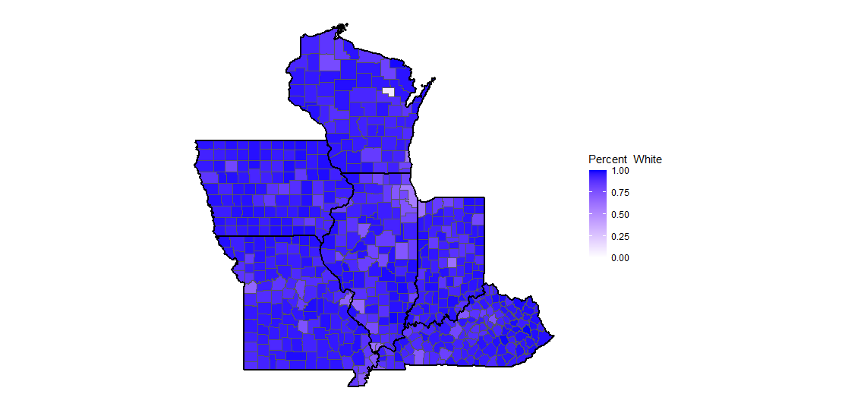
ggplot(core)+
geom_sf(aes(fill = pctClinton))+
scale_fill_gradient(low="red",high="blue",limits=c(0,1),
aes(name="Percent Clinton"))+
theme(panel.grid.major = element_blank(),
panel.grid.minor = element_blank(),
panel.background = element_blank(),
axis.text.x=element_blank(),
axis.text.y = element_blank(),
axis.line = element_blank(),
axis.ticks = element_blank()) +
geom_sf(
data = States,
fill=NA, colour="black",
size=1,
inherit.aes=FALSE
)

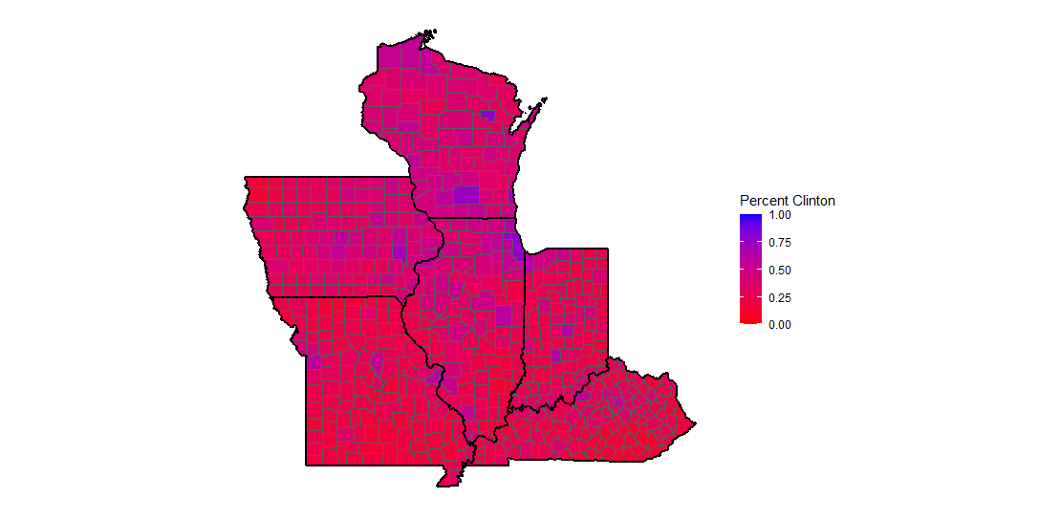

Simple Regressions

Now that we have the core data, we can run the regressions. Again, the command we use is lm() and the structure is such that we list the dependent variable followed by the squiggle (~) and then the independent variables separated by plus (+) signs. The second element of the simple regression is to tell the command where the data comes from using the data= option. The lm() command automatically assumes the existence of the intercept term, however, if you wish to remove it, all you need do as add the term ‘-1’ to the end of the line of independent variables. Both commands regressing the percentage of votes for Clinton against the percentage of the population that is white are below.
mod1<-lm(pctClinton~perWhite, data=core)

mod2<-lm(pctClinton~perWhite-1, data=core)

The regression results are return in a list object of the names mod1 and mod2. If you click on either name in the environment window you will see each list contains a great deal of information from coefficient estimates to residuals. We can simply the output by using the command summary() to give us a standard regression results output.
> summary(mod1)

Call:
lm(formula = pctClinton ~ perWhite, data = core)

Residuals:
Min 1Q Median 3Q Max
-0.25975 -0.06905 -0.01371 0.06797 0.37180

Coefficients:
Estimate Std. Error t value Pr(>|t|)
(Intercept) 1.13494 0.04860 23.35 <2e-16 ***
perWhite -0.89552 0.05222 -17.15 <2e-16 ***
---
Signif. codes: 0 ‘***’ 0.001 ‘**’ 0.01 ‘*’ 0.05 ‘.’ 0.1 ‘ ’ 1

Residual standard error: 0.09598 on 597 degrees of freedom
(2 observations deleted due to missingness)
Multiple R-squared: 0.33, Adjusted R-squared: 0.3289
F-statistic: 294.1 on 1 and 597 DF, p-value: < 2.2e-16

We see that we have a negative coefficient that is statistically significant at the highest level indicating that for each one percent increase in the white population share of a given county, the vote share the candidate Clinton received fell by just under one percent.
> summary(mod2)

Call:
lm(formula = pctClinton ~ perWhite - 1, data = core)

Residuals:
Min 1Q Median 3Q Max
-0.22835 -0.08659 -0.02239 0.07631 0.75901

Coefficients:
Estimate Std. Error t value Pr(>|t|)
perWhite 0.320058 0.005824 54.95 <2e-16 ***
---
Signif. codes: 0 ‘***’ 0.001 ‘**’ 0.01 ‘*’ 0.05 ‘.’ 0.1 ‘ ’ 1

Residual standard error: 0.1327 on 598 degrees of freedom
(2 observations deleted due to missingness)
Multiple R-squared: 0.8347, Adjusted R-squared: 0.8344
F-statistic: 3020 on 1 and 598 DF, p-value: < 2.2e-16

Without the coefficient we see that for each additional percentage of white population in a county, Clinton’s vote share increased by only about 0.3 percent. The way to interpret these two seemingly different results is that the former starts Clinton off with a 1.13 percent advantage whereas the latter starts both candidates off with a zero percent. The coefficient on the same regression with Trump in place of Clinton sees a coefficient of about 0.75. Therefore, if a county has 80% of the population as white, then Clinton would have about 24% of the vote while Trump would have about 60% of the vote. Of course, these are just simple correlations between the vote and the percentage of whites. To gain more insight, we need additional control variables.
Call:
lm(formula = pctClinton ~ perWhite + perMale + perCit + perSameCounty +
perSameSt + perOthState + perAbroad, data = core)

Residuals:
Min 1Q Median 3Q Max
-0.23640 -0.06268 -0.01336 0.05834 0.30785

Coefficients:
Estimate Std. Error t value Pr(>|t|)
(Intercept) 2.61202 0.28557 9.147 < 2e-16 ***
perWhite -0.67201 0.05779 -11.628 < 2e-16 ***
perMale -0.38936 0.25890 -1.504 0.13315
perCit -1.51528 0.26608 -5.695 1.95e-08 ***
perSameCounty 0.23836 0.17991 1.325 0.18571
perSameSt -0.28264 0.22999 -1.229 0.21959
perOthState -0.69499 0.29830 -2.330 0.02015 *
perAbroad 4.64841 1.68334 2.761 0.00593 **
---
Signif. codes: 0 ‘***’ 0.001 ‘**’ 0.01 ‘*’ 0.05 ‘.’ 0.1 ‘ ’ 1

Residual standard error: 0.09014 on 591 degrees of freedom
(2 observations deleted due to missingness)
Multiple R-squared: 0.4149, Adjusted R-squared: 0.408
F-statistic: 59.88 on 7 and 591 DF, p-value: < 2.2e-16

Call:
lm(formula = pctClinton ~ perWhite + perMale + perCit + perSameCounty +
perSameSt + perOthState + perAbroad + factor(state), data = core)

Residuals:
Min 1Q Median 3Q Max
-0.257777 -0.046645 -0.004957 0.041876 0.201264

Coefficients:
Estimate Std. Error t value Pr(>|t|)
(Intercept) 2.389018 0.215362 11.093 < 2e-16 ***
perWhite -0.696401 0.044347 -15.703 < 2e-16 ***
perMale -1.095687 0.196135 -5.586 3.55e-08 ***
perCit -0.950193 0.203165 -4.677 3.62e-06 ***
perSameCounty 0.486499 0.135017 3.603 0.000341 ***
perSameSt 0.441742 0.175904 2.511 0.012298 *
perOthState -0.088085 0.229449 -0.384 0.701193
perAbroad 2.568805 1.259219 2.040 0.041798 *
factor(state)indiana -0.027898 0.009844 -2.834 0.004753 **
factor(state)iowa 0.047629 0.009840 4.840 1.66e-06 ***
factor(state)kentucky -0.068739 0.009314 -7.380 5.43e-13 ***
factor(state)missouri -0.082479 0.009708 -8.496 < 2e-16 ***
factor(state)wisconsin 0.109047 0.010413 10.472 < 2e-16 ***
---
Signif. codes: 0 ‘***’ 0.001 ‘**’ 0.01 ‘*’ 0.05 ‘.’ 0.1 ‘ ’ 1

Residual standard error: 0.06703 on 586 degrees of freedom
(2 observations deleted due to missingness)
Multiple R-squared: 0.6792, Adjusted R-squared: 0.6727
F-statistic: 103.4 on 12 and 586 DF, p-value: < 2.2e-16
By adding the additional control variables, we get a slightly better fit of our data and see that we get statistically significant coefficients for the percentage of the population that is White, Male, Citizen, moved from another state, and are from Abroad and in all the last case, the coefficients are negative.

Identifier (Dummy) Variables

This analysis ignores any state level affects such as the fact that Illinois is a safe democratic state while Indiana and Kentucky are safe Republican states. To include fixed effects for an identifier variables, such as states or years, we can simply add the factor() option to our lm() command. This keeps us from having to create a series of dummy variables that we then must list in our lm() command individually. We could; however, do this using our case_when() command we used in our last lecture if we wished to.

Other Elements in the model list

Looking through the model list that is generated, we see that it creates a set of fitted values. This can be useful if we want to show the difference between the actual and fitted values, a scatter plot of the dependent and an independent variable with the fitted line, or a plot of residuals. All three are shown in plots below using our ggplot2 package.
#Plotting other elements of the mod List
p1<-ggplot(core, aes(x=perWhite))+
geom_point(aes(y=pctClinton))+
xlim(0,1)+
xlab("Percent Population White")+
ylim(0,1)+
ylab("Percent Clinton")+
geom_line(aes(y=mod1$fitted.values), color="red")+
theme_bw()
p1

Here we see the scatterplot for the percentage of votes for Clinton and the percentage of the population for Whites and then we add the fitted line using the fitted values produced by the regression model.

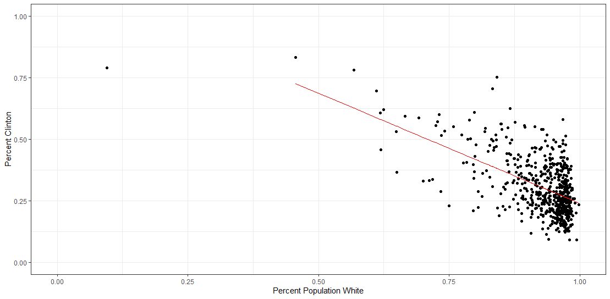

We can also graph the residuals. Here though we need to create the observation number for the x value of the graph and so we use the seq() command to just create a sequence of values from 1 to 600.

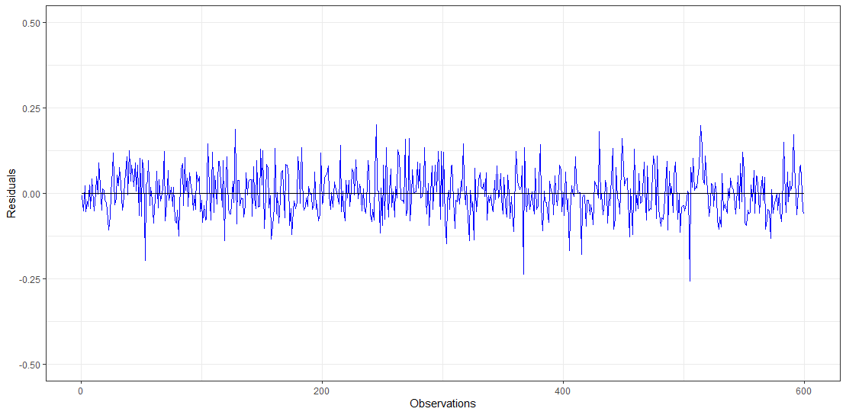
The other factor to notice in our graph command is the use of the theme_bw() option which simplifies the look of the graph. There are several of these themes built into ggplot2 that you can choose from to give the graphs standardized looks without having to set all the parameters.

Displaying results

When publishing results, we need show our results together in a single table rather individual tables and we also need to show a table of our summary statistics. We could output the values to a text file and then modify the table inside a program such as Excel or we find a package to output our regression results and summary statistics in an organized way that allows us to still do some customization. Three packages I have found useful are jtools [summ()], stargazer, and finalfit. Of the three, stargazer is the easiest to use; however, there are cases when stargazer does not support the model type (such as survival models) and you will need another package. You can google search each of these for documentation to use; we will focus on using the stargazer package.

The regression results can be output in one of three ways: (1) on screen in the console, (2) as an html file, (3) as a text file, or (4) latex script. These are identified with the type= option in the code and the out= tells R where to save the selected output. Typically, I will use html if I am going to load the table into Word or Excel. If (or rather when) you work with latex, you will be able to output the script and then just drop it into your latex document to produce the table.

Another nice feature of stargazer is that it can distinguish between summary statistics and regression model output and produce nice tables for the respective data. Before we can create the summary statistics for our data; however, we need to remove the geometry column to change this from an sf object. We will also get rid of a couple of other columns as well. NOTE: the only way to get rid of the geometry column is to use the command df$geometry<-NULL.
core.2<-core %>%
select(-c(GEOID, area))
core.2$geometry<-NULL

stargazer(core.2, type="html", out="./Build/Output/SumStat.html")

stargazer(mod1, mod2, mod3, mod4, type="html", out="./Build/Output/regress.html")

We can also report the results of a series of models using the stargazer package and command.

We can easily change any of the features of these tables using the options within the stargazer package or we can export them and then modify them further in whatever we are creating our presentation within.

